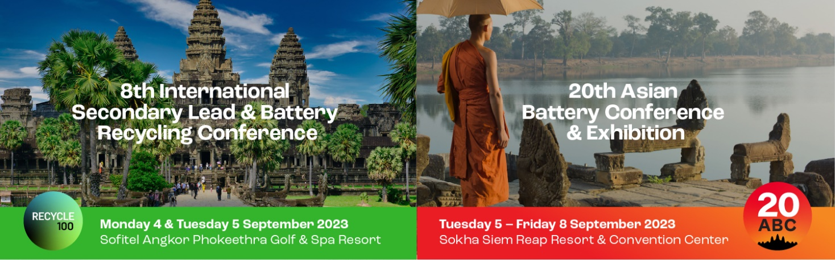

**Invitation Letter**

[insert dd month] **2023**

**Regarding:** Title [insert title] Given and surname: [insert give and surname]

**DOB:** [insert dd month yyyy]

**Nationality:** [insert nationality]

**Passport number:** [xxxxxxx] Expiry: [dd Month yyyy] **Position:** [insert position title]

**Organisation:** [insert organisation]

To Whom it May Concern,

The Conference Management Office advises that [insert given and surname] is invited to attend the conferences detailed below:

Event: Recycle100 8th International Secondary Lead Conference   
Venue: Sofitel Angkor Phokeethra Golf & Spa Resort

20th Asian Battery Conference and Exhibition

Dates: 4 – 8 September 2023

Venue: Sokha Siem Reap Resort & Convention Center, Cambodia

With the focus of battery production centred in Asia, the conference is a must for those seeking to expand their knowledge, contacts and stay up to date with new and emerging technologies, delegates will benefit highly from the event.



Regards,

**Conference Works**